# Table of Contents

**Network-as-a-Service Runbook**

***MOP Power Equipment Installation Template***

**<NaaS Operator’s Name>**

**

*<Release Date>*

Table of Contents 1

1 Document Control 3

2 About Design Template 4

2.1 Document Purpose 4

3 Access Request 5

4 Health & Safety Measures 5

5 Pre-Installation 6

5.1 Site Material Received 6

5.2 Details of tools and testers 7

5.3 Verify Weather Conditions 8

5.4 Winch Installation 8

6 Connection Diagram 8

7 Equipment Description 8

8 IDU Installation 9

9 ODU Installation 10

9.1 Locate ODU position 10

9.2 ODU Lifting. 11

9.3 Installing the ODU on a Pole 12

10 Cable Installation 16

10.1 Installing Grounding Cables 16

10.2 Installing Power Cables 16

10.3 Installing Signal Cable 17

10.4 Installing the Opting Fiber 17

10.5 Intermediate Frequency Cable 18

11 Antenna Adjustment 18

12 Commissioning 22

13 Labeling 26

14 Annex A 26

# Document Control

- Revision Control sheet allows to maintain a record of changes made on the document.

|  |  |  |  |
| --- | --- | --- | --- |
| Version N° | Issue Date | Status | Reasons for Change |
|  |  |  |  |
|  |  |  |  |
|  |  |  |  |
|  |  |  |  |

Table 1. Revision History

# About Design Template

## Document Purpose

The purpose of this document is provide guidelines and a sample of a Installation Method of Procedure of a Microwave backhaul equipment of any kind.

# Access Request

* The Access Request Form must include the following:
* Name, Position and ID of the Tower Access Seeker proposing to access the Tower,
* Details of the company for which the Tower Access Seeker works,
* Site on which the Tower is located,
* Proposed date(s) and time(s) of access and proposed duration of the works,
* Purpose of the access,
* Equipment that will be required for the works,
* Scope of Works (SOW),
* Method of Procedure (MOP),
* Safe Work Method Statement (SWMS),
* License or certification for the operation of any major equipment to be used , for example using an elevated work platform (EWP), scissor lift or cherry picker, Copy of Climbing
* Certificates / licences (riggers),
* Copy of Tower Rescue Certificates (riggers),
* Copy of Medical Certificates,
* Copy of First Aid certificates,
* Any other information required by applicable work health and safety laws and regulations for applicable jurisdictions (for example in NSW the Work Health and Safety Act 2011 (NSW) and Work Health and Safety Regulations according to local regulations (NSW)).

***Insert the Naas Operator Access Procedures***

# Health & Safety Measures

* Before any person shall commence a tower climb, they must:
* Familiarize themselves with the risks at the Site and on the Tower and understand the risks
* Inherent in working in an RF environment and be aware of the “go/no go” designated areas.
* Be fully conversant with the operation of all safety equipment and techniques; and
* Take into consideration current and predicted weather conditions and take the requisite
* Precautions to prevent exposure and potential slip hazards.
* During the climb each person must:
* Limit their work on the Tower solely to the area and work approved on the Tower Access
* Request Form and within daylight hours on a Monday to Friday basis,
* carry a means of portable communications,
* Verify the presence of fire extinguisher and first aid Kit

All NaaS Operator Field Workers that will work in tower site must wear their PPE this requisite is mandatory :

|  |  |  |
| --- | --- | --- |
| Panoramic eye protectors |  |  |
| Helmet with chinstrap for work at height |  |  |
| Dielectric safety footwear |  |  |
| High abrasion gloves |  | Abrasion Resistant Work Gloves | Aviation Spares & Repairs |
| Dielectric gloves |  |  |
| Full body safety harness |  |  |
| Double lashing strap (monkey tail) |  |  |
| Suspension strap |  |  |
| Positioning belt |  |  |
| Life rope |  |  |
| Save sliding falls (lifeline) |  | Miller Guide - Smart Policy Safety Compliance at Height |
| Safety belt |  |  |

***Insert the Naas Operator Health and Safety Procedures***

# Pre-Installation

## Site Material Received

|  |  |  |  |
| --- | --- | --- | --- |
| **SI Code** | **Description** | **Serial** | **Comments** |
| BATCAB01 | Battery Cabinet | SN12334553 | NA |
| BREAK02 | Breakers | SN 234364 |  |
| ACPDU03 | AC PDU | SN 56735 |  |
| BAT04 | Battery | SN 568 |  |
| PWRSH03 | Power Shelf | SN 789 |  |
| RECT05 | Rectifier | SN 234 |  |
|  |  |  |  |

***Insert the Naas Operator Equipment and Material List***

## Details of tools and testers

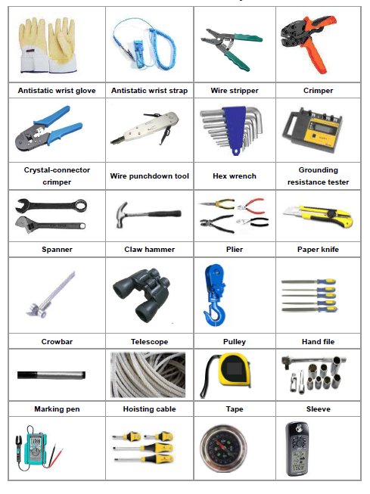

***Insert the Required Tools to perform the Installation***

## Verify Weather Conditions

Winds higher than 30 km / h, ice formation and/or snow accumulation, its required to suspend work at height, except critical areas, where works must have an authorization explicitly by engineering and must be informed the chief of operations before implementation.

# Connection Diagram



*Depending on the complexity of the scenario the connection Diagram could cover all connections in a single diagram or may be split*

# Equipment Description





# Battery Cabinet Installation

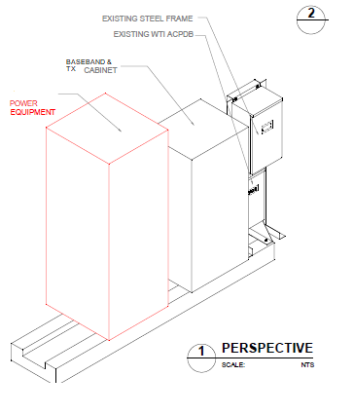

***Insert a Schematic Diagram that reflects where the Power Cabinet will be Installed***

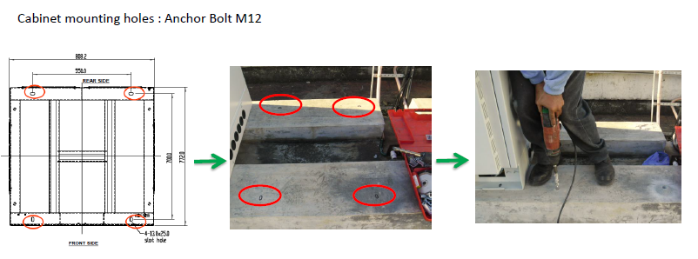

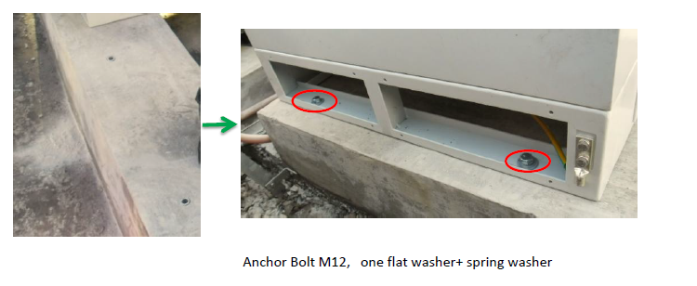

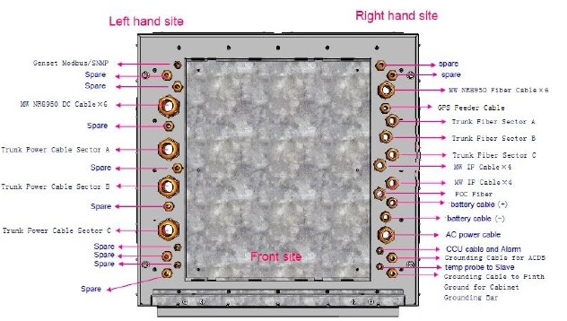

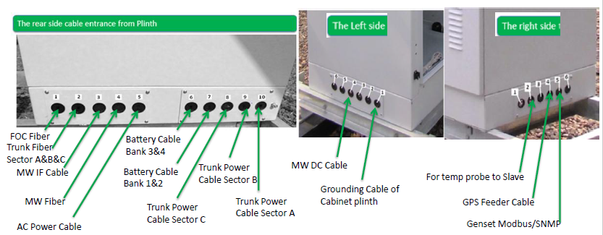

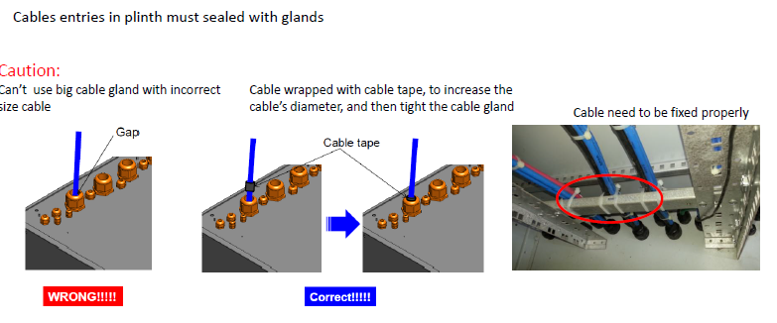

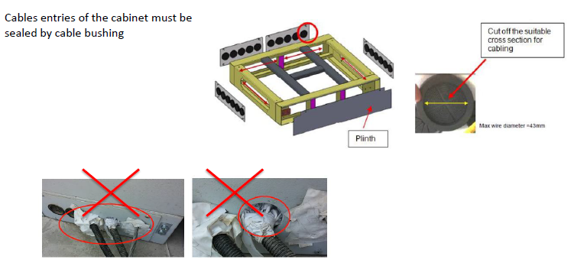

***Insert STEP BY STEP Instructions to Mont the Power Cabinet***

# Cabinet Cabling

## AC Power Cable

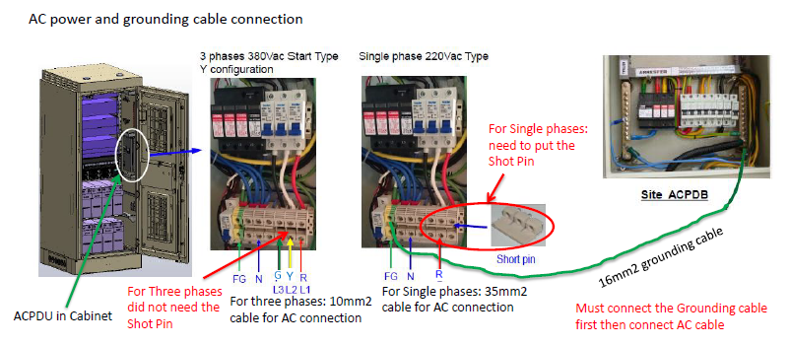

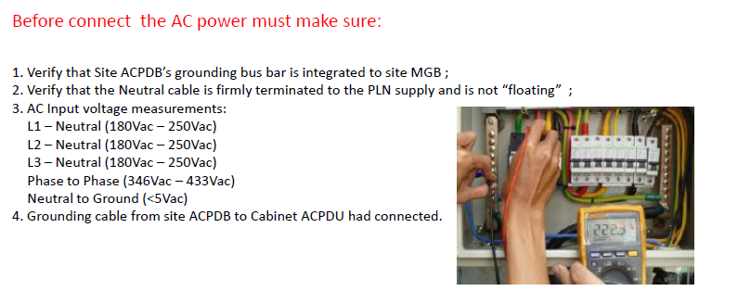

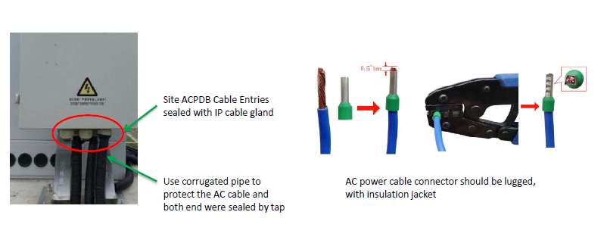

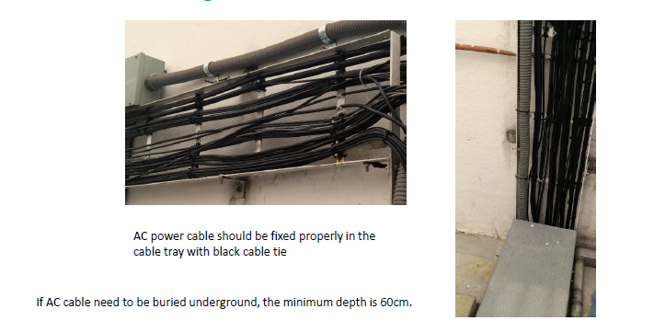

***Insert detailed instructions to connect the AC Power from grid***

## DC Power Cable

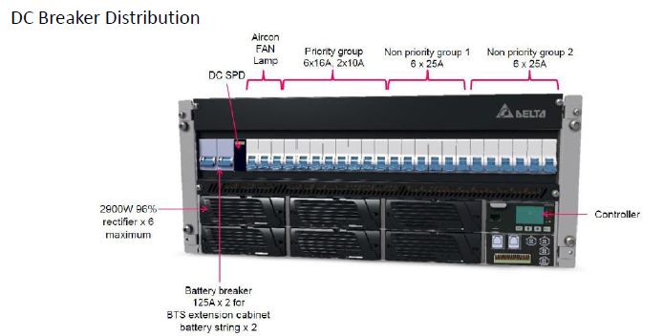

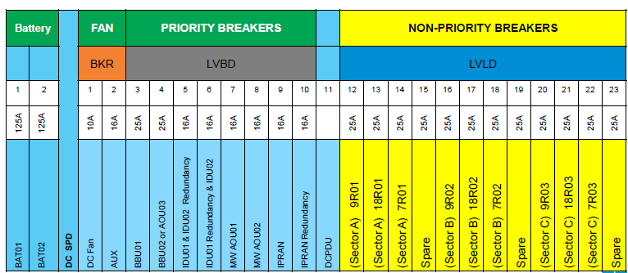

***Define a position to connect the Base Station Elements to the DC Power Breakers***

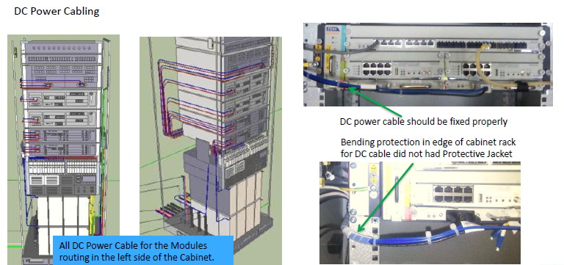

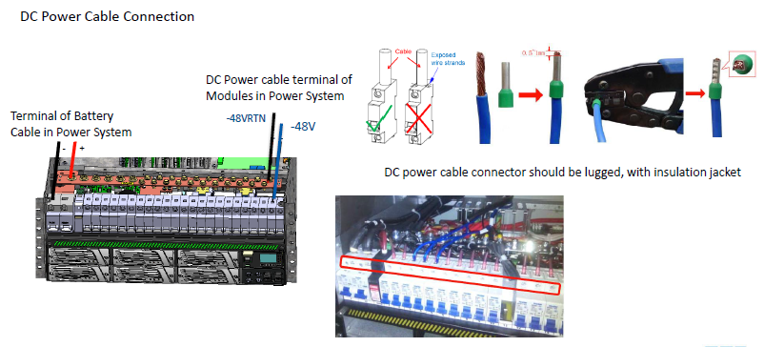

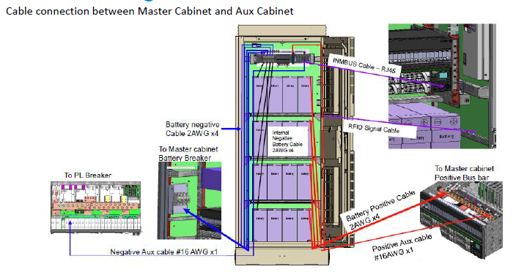

***Insert Step by Step instructions to connect DC cables into the Power Cabinet***

## Battery Cabling

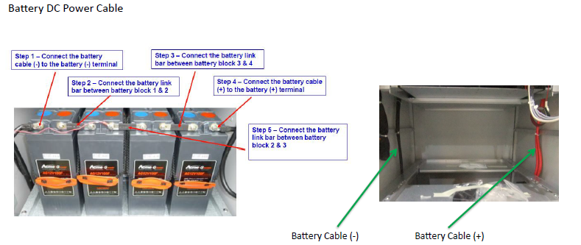

***Insert Step by Step instructions to cable the batteries into the cabinet***

# Cable Installation

## Installing Grounding Cables

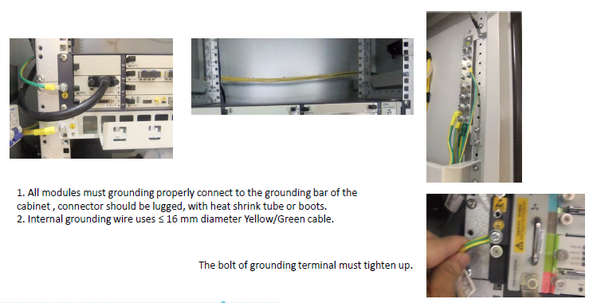

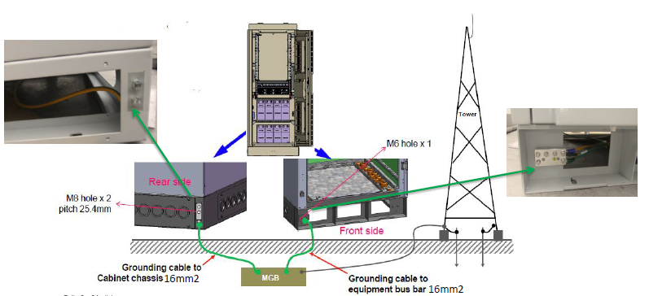

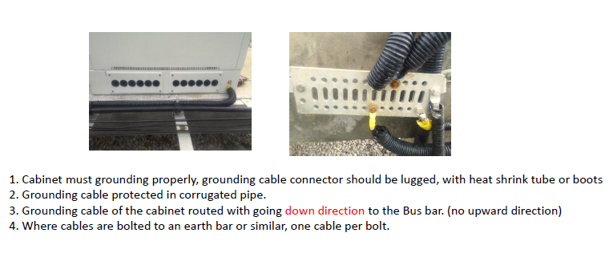

***Insert Step by Step Instructions to ground the equipment***

## Installing Power Cable for Tower Elements

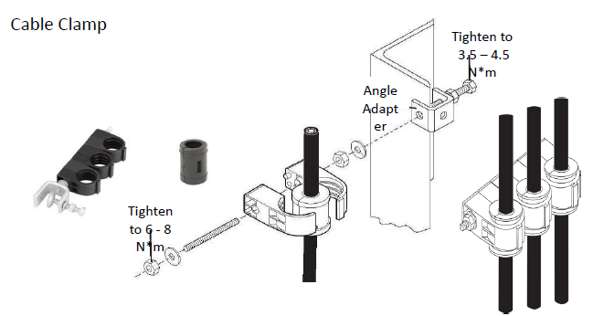

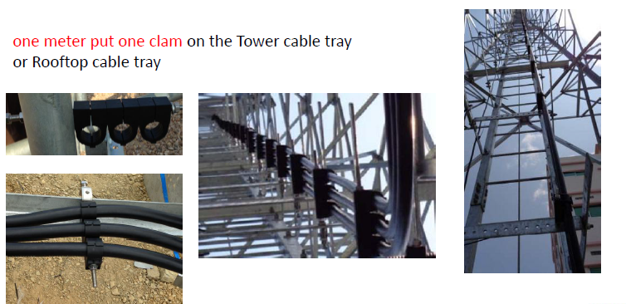

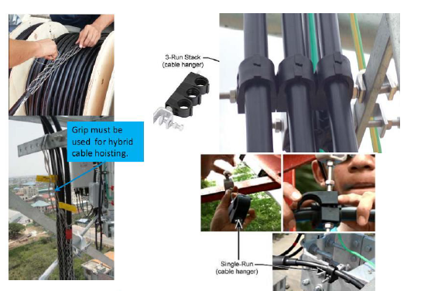

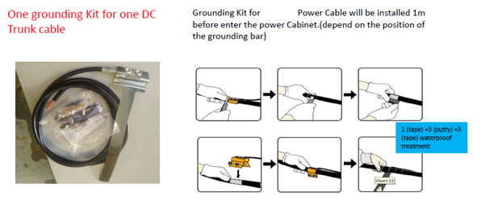

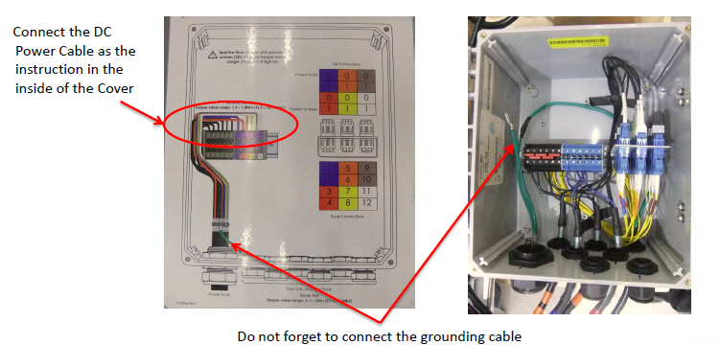

***Insert Step by Step instructions to deploy power cables along the tower***

# Labeling

# Annex A

Additional supporting information that should not be included in the document:

* Antenna Azimuth